Practicum Case | 
COMP6885 | COMP6885001
Natural Language Processing
Computer Science | O251-COMP6885-JD01-07
Valid on Odd Semester Year 2024/2025 | Revision 00

Learning Outcomes
- LO2 - explain Explain fundamental concepts of how to work with Natural Language Processing
- LO3 - apply Natural Language Processing concepts in certain real-world applications
- LO4 - construct Natural Language Processing applications

Topic
- Session 07 – Language Model (N-Grams)

Sub Topics
- Language Model (N-Grams)

Soal
Case
Learning Language Model (N-Grams)

You have a senior programmer that taught you how to use Language Model (N-Grams). Your task is to review the process by doing this step:
- First you will use this data in your code:
corpus = [
'Try to Learning',
'Natural Language Processing',
'In Software Laboratory Class'
]

query = 'Try Query the Natural Language Processing Corpus'

- Then create the N-Grams Language model with n = 2. After that get the Cosine similarity between the corpus data and the query data using the N-Grams model.
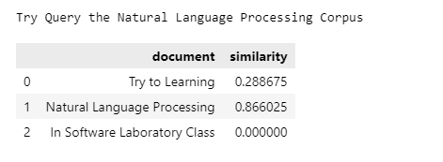
Figure 1. Result

